New Possible Approach in Treatment of Experimental Induced Vaginal Atrophy by Bone Marrow-Derived Mesenchymal Stem Cells in Adult Female Albino Rats (histological, immunohistochemical and biochemical study)

Eman Mohamed Faruk¹, Sherifa Abd El-Salam¹, Samia Mahmoud Manawy² and Naglaa Yehia Nafie³
Departments of Histology and Cytology¹, Anatomy² and physiology³ Faculty of Medicine - Benha University

Abstract
Women after menopause have a lot of complains that negatively distress their life. In the modern years, a lot of conduction methods have been presented to relief undesirable symptoms. Bone marrow mesenchymal stem cells (BM-MSCs) can be recently used as a new therapeutic method in treatment of many diseases and avoidance the hormonal sides effects that happened after menopause.
Aim: The aim of this research is to show a new approach in modification of the structure of vaginal mucosal atrophy by uses of (BM-MSCs) in induced ovariectomized rats.
Methods and Results: Fifty- five female albino rats were used and divided randomly into five groups: control group, ovariectomized group, ovariectomized group plus estrogen (20ug /kg/day for 4 weeks), ovariectomized with BM-MSCs (107 MScs/rat intravenously) and ovariectomized rats with stem cells /BM-MSCs Intra-vaginal group, the expression of genes for GAPDH, iNOS and TGF-β were done and vaginal biopsies were taken for histological and immunohistochemical studies. In ovariectomized group there was inflammation, ulceration and re- epithelialization with irregularity in collagen fibers, decreased estrogen receptors expression and expression of TGF-β, GAPDH and iNOS were very high. While the rate of healing of epithelium was increased with increased in the vasculatures of vaginal mucosa and the estrogen receptors expression was high with decreased expression of GAPDH, iNOS and TGF-β in ovariectomized rats that treated with intra- vaginal BM-MSCs.
Conclusions: Using the BM-MSCs could be used intravaginal safely in case of vaginal atrophy as they modify the structure of vaginal mucosa than estrogen hormone therapy alone.
Keywords: vaginal atrophy, BM-MSCs, estrogen

Introduction:
Females suffer from general and local changes which appear after menopause. These changes are due to decrease in the level of estrogen (1). This may be physiologically at menopause or occur accidentally after surgical removal of ovaries ((2). This decrease in estrogen level has many physiological changes as vasomotor instability, mood changes, an increased risk of osteoporosis and vaginal atrophy (3). Vaginal atrophy is a common and affects more than 40% of postmenopausal females. This atrophy causes thinning and shrinking in the vaginal epithelial wall and decrease in smooth muscle fibers with less elasticity of vaginal wall (4). Vaginal atrophy causes burning, dryness, irritation, and dyspareunia (5). These symptoms do not improve with time and are not resolve without treatment (6). The good level of estrogen from puberty is essentially for good blood supply for vaginal mucosa and its lubrication (7). The vaginal wall rugae, wall thickening and lubrication are depending on presence of estrogen (8). Vagina is estrogen dependent organ as estrogen is responsible for induction of proliferation of vaginal epithelium layers, smooth muscles and collagen fibers so maintains vaginal rugae (9). Experimental bilateral ovariectomy were done to know the effects of decrease in hormonal levels and their activity in female rats (10). This experimental ovariectomy has an important role to understand the pathophysiological changes and to help in developments of therapy (11). So, to improve pathophysiological changes after ovariectomy, estrogen therapy was used as a replacement therapy, but there are many limitations for hormonal uses because its side effects and hazards as, cancer specially, breast, ovaries or uterus. Also, causes cardiovascular hazards or thrombosis (12). These side effects can be controlled through good monitoring, mammography and endometrial thickness measurement (13). To avoid risk of hormone replacement searches done to establish other line of treatment. Embryonic and somatic stem cells proved that they can be differentiated into female germ cells (14). Somatic cells also appear to differentiate into granulosa and theca cells of the ovarian follicles which are responsible for production of estradiol (15). The aim of this study is to explore the role of estrogen hormone in restoring histological changes of vagina after ovariectomy and to assess other lines of therapy as MSCs to improve histopathological changes in ovariectomized rat.
Material and Method:
Animals
Fifty adult female rats weighing 160 ± 200 g were obtained from the Animal House, Moshtohor Faculty of Veterinary Medicine, Benha University. Rats were kept under observation for 1 week before the beginning of the experiment for accommodation. They were maintained in a temperature- and humidity-controlled room and given free access of water and food. All animal experiments were conducted in accordance to approved protocols and the recommendations for the proper care and use of laboratory animals.
Experimental design
Fifty-five female rats (eight to ten weeks old) were taken and divided into five groups each group 10 rats and five rats were prepared for isolation and culture of MSCs.
Group I: (-ve control): no surgical operation.
Group II: (ovariectomized group): In this group the rats under grow ovariectomy operation (15).
Group III: (ovariectomized group plus estrogen): rats treated by natural estrogen (estradiol) injected subcutaneously in a dose of 20ug /kg/day for 4 weeks (16).
Group IV: (ovariectomized rats with BM-MSCs): (rats were injected once by 10⁶ MScs/rat intravenously (through tail vein) and scarified after 6 weeks.
Group V: (ovariectomized rats with stem cells /BM-MSCs Intra-vaginal group): rats were injected once with 106 MScs/rat into the subepithelial space intravaginal and scarified after 6 weeks (17).
Ovariec tomy technique: The rats were anesthetized by ether inhalation. Under sterile conditions, a 2–3 cm ventral lower midline incision was made into the skin and muscle (to expose the ovaries). After good homeostasis, the ovaries were removed after tying off and cut from the oviduct. Antibiotics were applied locally before suturing the muscles and the skin to close the incision. The anoestrus phase was considered to be occurring 15 days after surgery. To confirm this phase, the oestradiol level was tested 15 days after surgery, to compare oestradiol hormonal levels pre and post-surgery. At the time anoestrus was confirmed in all groups we began the treatment by estradiol or stem cells (18).
Isolation, culture, identification of BM-MSCs and Labeling Stem Cells with GFP
All procedures were performed according to “Guide for the Care and Use of Laboratory Animals” in which bone marrow samples were taken from tibiae and femurs of five female white albino rats and flushing with Dulbecco's modified Eagle's medium (DMEM, GIBCO/ BRL) , then were added to 10% fetal bovine serum (GIBCO/BRL) and the nucleated cells were isolated with a density gradient (Ficoll/Paque [Pharmacia]) and were suspended in complete culture medium supplemented with 1% penicillin- streptomycin (GIBCO/BRL). Cells were incubated at 37oC in 5% humidified CO2 for 14 days as primary culture to formation of large colonies. When large colonies developed (80∼90% confluence), cultures were washed twice with phosphate buffer saline (PBS) and the cells were trypsinized with 0.25% trypsin in 1mM EDTA (GIBCO/BRL) for 5 min at 37oC. After centrifugation, cells were suspended with serum-supplemented medium and incubated in 50 cm2 culture flask (Falcon). The resulting cultures were referred to as first-passage cultures (19). MSCs in culture were characterized by their adhesiveness and fusiform shape (18). At passage 6, cellular expression of CD29, CD44 (HPA005785 Sigma-Aldrich, St. Louis, MO, USA) were evaluated by flow cytometry.
For MSCs labelling the cell were taken at passage 4, and labeled with GFP (
AAA27722 Sigma-Aldrich, St. Louis, MO, USA). MSCs were infected by using the MSC Nucleo fector Kit and a plasmid encoding the fluorescent protein GFP. Cells were centrifuged, washed twice in serum free medium, then put in nucleo fector solutions. A final concentration of (4 - 5) × 105 cells/100 μl nucleo fector solutions was applied. The sample was placed in cuvette of elactroporation transfection instrument at program U-23 (for high transfection efficiency) or C-17 (for high cell survival). 24 hours post-nucleo fection cells were analyzed by fluorescence microscopy. Transfection efficiencies of around 80% can be reached with GFP. Labeled cells were injected intravenously in ovariectomized rats. All rats at end of experiment were sacrificed and vaginal tissue was prepared d for histological, immunohistochemical examination and real time PCR analysis vaginal tissue was examined with a fluorescence microscope (Leica, Germany) to detect the cells stained with GFP.
hormonal assay of serum FSH and E2
Blood samples were taken and collected from tail vein then centrifuge 5.000rpm for 15 min to separate serum to estimate FSH and E2 hormones using ELISA kits [CUSABIO, USA]. This estimation of hormones done every fifteen days to estimate ovarian function till the end of experiment (20).
Histological Examination
Vaginal tissue samples were divided into two sections. The first section was examined by fluorescent microscope for tracing of injected labeled cells with GFP. The second sections were processes for paraffin block and stained with hematoxylin and eosin (H&E) and sirius red (for demonstration of collagen fibers) (21).
Immunohistochemistry
Immunohistochemical staining for estrogen receptors were performed on 5-μm, formalin-fixed, paraffin-embedded sections by using the streptavidin-biotin detection system (DAKO). They were obtained from sigma company and kit (SRP2163-4UG). Human prostate (taken from the pathology department in our institution) served as a positive control according to Manufacturer Company. Negative control slides were prepared by the same steps, except they were incubated with the antibody diluent instead of primary antibody. Positive reaction for estrogen receptors appeared in the form of brown nuclear staining (22).
RNA Extraction and Quantitative real-time polymerase chain reaction (qRT-PCR)
Vaginal tissues of all studied groups were homogenized and total RNA was isolated with RNA easy Mini Kit (Qiagen) then analyzed for quantity and quality with Beckman dual spectrophotometer (USA). Quantitative real-time polymerase chain reaction was done as following, 200ng of total isolated RNA from each sample were used for DNA synthesis by reverse and transcription method by using High capacity cDNA Reverse Transcriptase kit (Applied Biosystem, USA) to measure the quantitative amount of Inos, GAPDH and TGF-β genes. Then the DNAs were amplified with the Syber Green I PCR Master Kit (Fermentas) in a 48-well plate using the Step One instrument (Applied Bio-system, USA). Primers sequence for each gene demonstrated as Ions:
CCACCCATGGCAAATTCCATGGCA(Forward),TCTACACGGCAGGTCAGGTCCACC(Reverse);GAPDH:CAGGAGGATGGTGGTTTGAT (forward),TGCCACTTTATCCCATTCAG(Reverse);TGF-B: AAGTCATCCATCCCTTCAGC(forward),AGCCCACCTGAGCCCTATAA(Reverse).
Morphometric study
By using image analyzer (Image-Pro Plus program version 6.0 (Media Cybernetics Inc., Bethesda, Maryland, USA), from each group sections were measured in ten non-overlapping fields by high power field:
- mean vaginal epithelial thickness in each group (23).
-Mean area percent of collagen fiber content (±SD) in each group.
-mean area percent of estrogen immunostaining was quantified
Statistical analysis
One-way study of variance (ANOVA) was used to measure up differences between the groups and by using IBM SPSS Statistics software for Windows, Version 20 (IBM Corp., Armonk, NY, USA) we recorded and analyzed collected data from each group, all data was put across as the mean value, standard deviation(SD) and differences were considered to be significant at p< 0.01.
Result:
BM-MSCs identification and Homing
Undifferentiated (BMSCs) were appear as spindle and fibrocyte-like by inverted microscope (fig.1a) while flow cytometry analysis of surface molecule for CD29, CD44for confirmation of mesenchymal cell phenotypes (fig.1b). Florescence microscopy examination of vaginal cells treated by mesenchymal cells indicated that the GFP-transduced injected cells were localized within the vaginal tissue (fig.1c).

1A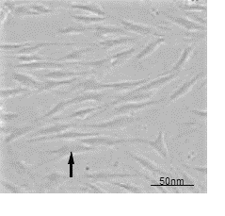1B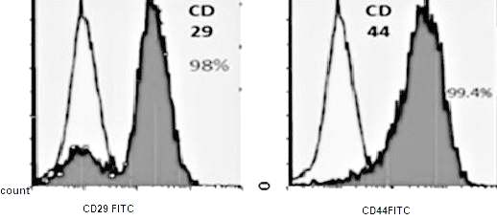
1C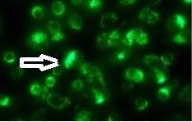1D
Figure (1) Photomicrographs of identification of bone marrow-derived mesenchymal stem cells 1A) showing spindle-shaped like cells (arrow) on two weeks from primary culture (inverted microscope). (×200) .1B) showing image analyzer positive foe CD29and CD44. 1C) Homing of green fluorescent labeled MCSs (arrow) from stem cells group in vitro.1D) labeled MSCs in vaginal tissue (arrow) invivo. (fluorescent microscope) (× 1000)
Hormonal assay results:
E2 levels were assessed 15 days and 30 days after injection of estrogen and MSCs
Results showed that there was a significant decrease in E2 levels in ovariectomized
group compared to control (12.5±1.72 after 15 days versus 60.32±12.8 in control rats, p< 0.001 and 10.1±3.5 after 30 days versus 62.1±12.4 in control rats p< 0.001). Use of either estrogen or MSCs led to a significant increase in E2 levels with more superior therapeutic effects with intravaginal MSCs as compared to MSCs (40.5±10.3, p< 0.05, 50.1±10.2, p<0.01 and 55.7±19.2 respectively after 15 days versus 60.32±12.8 in control rats and were more significant with estrogen or MSCs treated groups respectively after 30 days (50.9±10.2, 53.2±1.4 and 60.1±11.8, p<0.01) versus control group 62.1±12.4 (Table 1).
FSH levels were assessed 15 days and 30 days after injection of estrogen and MSCs.
There was a significant elevation of FSH levels in ovariectomized group compared to control group (85.6±19.1 versus 32.6±9.0 in control rats, p< 0.001 after 15 days, 92±14.2 versus 35.6±9.4 in control rats after 30 days respectively, p< 0.001). Use of estrogen and MSCs led to a significant decrease in FSH levels as compared to ovariectomized group (40.1±9.2 and 45.3±11.7 after 15 days, p< 0.05 and 38.2±5.1 and 43.3±6.2 after 30 days. Use of intravaginal MSCs did not lead to decrease in FSH levels as compared to control groups. (68.6±13.9 after 15 days, p<0.01 and 72.1± 6.5 after 30 days, p<0.01 versus 32.6±9.0 and 35.6±9.4 in control group, p< 0.05) (Table 1).
Table 1. Serum E2 and FSH levels in all groups.

Group | Estrogen level  (E2) (pg/ml) after 15 days of ovariectomy | Estrogen level  (E2) (pg/ml) after 30 days of ovariectomy | FSH level(mIU/liter) after 15 days of ovariectomy | FSH level(mIU/liter) after 30 days of ovariectomy
Control group | 60. 2±1.8 | 62.1±0.4 | 32.6±1.0 | 35.6±0.4
Ovariectomized group | 12.5±1.12* | 10.1±0.5* | 85.6±1.1* | 92.1±1.2*
Estrogen treated group | 40.5±0.3# | 50.9±0.2 # | 40.1±0.2 # | 38.2±1.1#
BM-MSCs treated group | 50.1±1.2 # | 53.2±1.4# | 45.3±1.7# | 43.3±0.2#
Intravaginal BM-MSCs treated group | 55.7±1.2# | 60.1±1.8 | 68.6±1.9# | 72.1± 0.5
# significant as p value < 0.05 versus ovariectomized group.
* significant as p value < 0.05 versus control group.

Histological results
Hematoxylin & Eosin and sirius red results
H&E examination of vaginal tissue from control group revealed normal non keratinized stratified squamous epithelium with multiple papilla, and cells appeared, densely packed, vacuolated with dark nuclei (fig.2A). The underlying connective tissue appeared thick with regular packed bundles of collagen fibers (fig.3B). In ovariectomized group the epithelium appeared thin desquamated with apparent many dilated blood vessels and inflammatory cells infiltration in underlying connective tissue and (fig.2C). The connective tissue was irregular arrangement and decrease in amount with dilated blood vessels (fig.2D). In estrogen treated group the covering epithelium appeared normal with well recognized basal layer with multiple dilated blood vessels (fig.2E), while the connective tissue appeared normal with regular bundles of collagen fibers with moderate in amount (fig.2F). In BM-MSCs treated group showed many protrusions in the basal surface of the epithelium (fig.2G), also connective tissue increase in amount with regularly appearance (fig 2H). The intravaginal BM-MSCs treated group showed many protrusions in the basal part of epithelium that appear as feet fixing the epithelium to the basement membrane indicated functionally vaginal epithelium (fig.2I), also their connective tissue differentiated into thick regular arrangement bundles of collagen fibers (fig2J).
The morphometric result of mean vaginal epithelial thickness revealed of 189.10±10.26 mm, 27.80±2.14 mm, 128.19±5.98 mm, 165.74±1.30 mm and 180.79±3.90 in Groups I, II, III, IV, and V respectively (Table 2). The mean thickness of the vaginal epithelium of rats in Group I (permanent estrus) was significantly greater than that of animals in Groups II, III (po0.0001), with no statistically significant differences between groups, IV and V. (p=0.0709).
The morphometric result of Mean area percent of collagen fiber content (±SD) in the studied groups revealed a significant decrease in groups II, as compared to the control group and values recorded for groups III, IV and V represented a statistically significant decrease, as compared to the ovariectomy group. However, the values were not statistically significant as compared to the control (table 2).

2A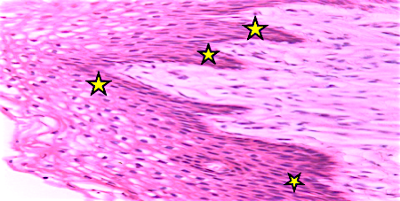2B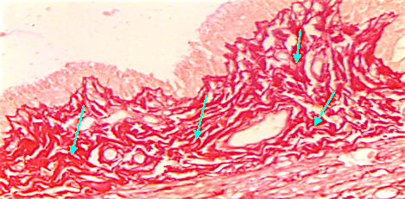
2C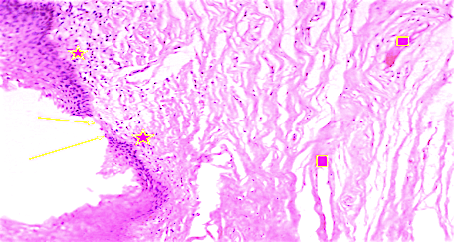2D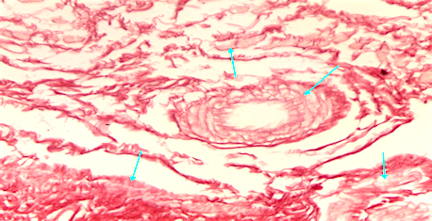

2E 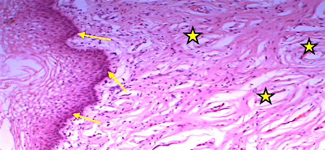 2F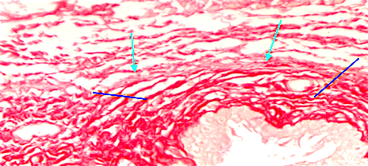

2G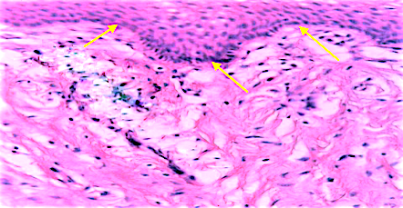 2H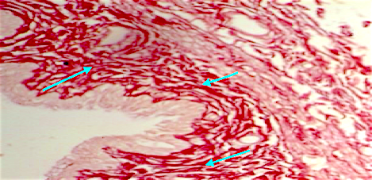

2I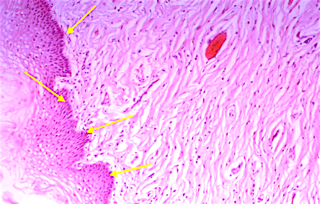 J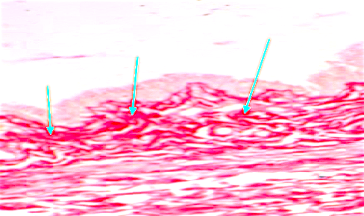

Fig. 2. A) A photomicrograph of a section of the vagina of adult control group (group I) showing normal stratified squamous epithelium with multiple papilla (stars). Notice that the cells are densely packed, vacuolated with dark nuclei (arrows).H&E, ×400.B) The connective tissue is intensely stained with Sirius(arrows). Sirius, ×400.C) The epithelium of group II showing desquamation (arrows) with many dilated blood vessels in underlying dispersed connective tissue (squares). Notice inflammatory cells under epithelium (stars). D) The connective tissue is faintly stained by Sirius(arrows) with regular arrangement of collagen fibers. Sirius, ×400.E) The epithelium of group III showing normal epithelial cells with well recognized basal layer (arrows) with multiple dilated blood vessels (stars). H&E, ×400. F) the connective tissue is moderate staining with Sirius red (arrows). Notice that the regular arrangement of collagen fibers (blue lines). Sirius, ×400. G) The epithelium of group IV showing many protrusions in the basal surface(arrows). H&E, ×400. H) The connective tissue is moderate to strong staining by Sirius red (arrows). Sirius, ×400.I) The epithelium of group V showing many protrusions in the basal surface(arrows). H&E, ×400.J) The connective tissue is strongly staining by Sirius red (arrows). Sirius, ×400.
Table 2. Means and standard deviations (±SD) of the vaginal epithelium thickness, mean area percent of collagen fiber content (±SD) and mean area percent of estrogen immuno-expression of female rats in all groups.
Group | Means and (±SD) of the vaginal epithelium thickness (mm) | Mean area percent of collagen fiber content (±SD) | mean area percent of estrogen immuno-expression(±SD)
control group | 189.10±1.26 | 84.2±1.3 | 24.6±1.9
ovariectomized group | 27.80±0.14 * | 19.9±05* | 10.9±1.8*
Estrogen treated group | 128.19±2.98 # | 69.8±0.2 # | 17.1±0.2 #
BM-MSCs treated group | 165.74±1.30 # | 73.8±1.9# | 20.3±1.7#
intravaginal BM-MSCs treated group | 180.79±1.90# | 81.1±0.2 | 22.5±1.9#
# significant as p value < 0.05 versus ovariectomized group.
* significant as p value < 0.05 versus control group. (Group I exhibited a significantly greater epithelial thickness than Groups II, III and IV (p<0.0001) and no difference was observed between Groups II, III and IV (p=0.0809).

Immunohistochemical results
To assess the estrogen receptors of vaginal cells after MSC transplantation, strong estrogen receptors expression was detected in the epithelium and in connective tissue of control group (fig3A.), while the expression of estrogen was minimal in ovariectomized group (Fig. 3B), also moderate expression in the epithelium of estrogen treated group (Fig. 3C), mild to moderate in group BM-MSCs treated group (Fig. 3D) and severe expression in group treated with BM-MSCs intravaginal (Fig. 3E). The mean area percentage of estrogen for all groups was represented in Tables 2. There was a significant increase in mean area percent of estrogen immuno-expression of groups IV, V compared with group II.

A) 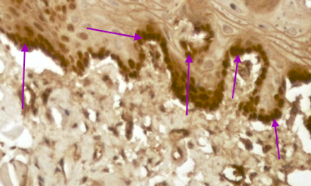 B)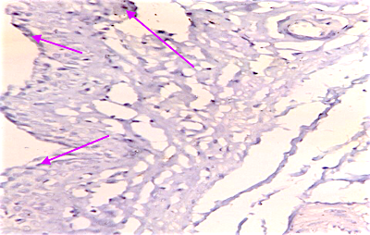
C ) 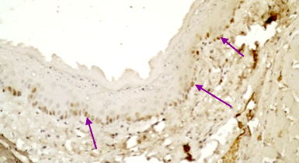 D) 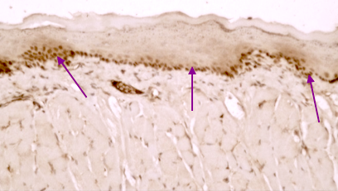
E) 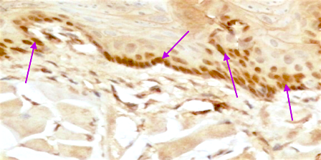

Fig. 3. A) A photomicrograph of a section of the vagina of adult control group (group I) showing strong positive estrogen receptor in epithelium (arrows). B) The epithelium of group II showing negative estrogen receptor (arrows) .C) The epithelium of group III showing mild to moderate estrogen expression (arrows). D) The epithelium of group IV showing moderate estrogen expression (arrows). E) The epithelium of group V showing moderate to severe estrogen expression (arrows). estrogen immunostaining ×400).

Quantitative Gene Expression
The expression of genes for GAPDH, iNOS and TGF-β in all groups were quantified by real-time PCR (Tables 3).
The expression of TGF-β was very low in healthy control vaginal tissue. After ovariectomy, the expression of TGF-β was very high. The treatment with BM-MSCs reduced TGF-β expression. The highest reduction of TGF-β expression was seen in group treated with BM-MSCs intravaginal.
The expression of Ions and GAPDH were absent in healthy control group while its expression increased after ovariectomy to reach very high expression after 6 weeks of ovariectomy. The treatment of ovariectomized rats with BM-MSCs reduced iNOS expression and significantly decreased in group treated with BM-MSCs intravaginal.

Table 3. Mean and SD of TGF-β, Ions and GAPDH genes expression for all groups,

Group | Means ±SD of the TGF-β gene expression | Means ±SD of Ions gene expression | Means ±SD of GAPDH gene expression
control group | 11.7±1.26 | 13.2±1.3 | 14.3±1.9
ovariectomized group | 22.14±0.14 * | 29.3±0.9* | 28.6±2.1*
Estrogen treated group | 12.19±1.28 # | 17.2±1.2 # | 18.1±0.2 #
BM-MSCs treated group | 14.24±0.52 # | 15.8±0.8# | 15.3±1.2#
intravaginal BM-MSCs treated group | 12.17±0.70# | 14.5±0.5 | 14.9±0.1#
# significant as p value < 0.05 versus ovariectomized group.
* significant as p value < 0.05 versus control group.

Discussion:
Menopause is a very important state in the life of females as it is associated with many changes in their health. Estrogen hormone deficiency after menopause or surgical removal of ovaries is responsible for these health hazards (24).
Ovary is the main organ for production of estrogen so ovariectomy causes decrease of this hormone (25). Decrease of estrogen is associated with elevation of follicular stimulating hormones (FSH). This increase of (FSH) is due to failure of negative feedback on pituitary effect as result of the decrease in ovarian hormones (26&27). Estrogen defects begin 15 days after ovariectomy (28).
In this study hormonal assay was done at 15 and 30 days after ovariectomy and showed that E2 levels were assessed and the results showed that there was a significant decrease in E2 levels in OVX group as compared to the control.
Use of either estrogen or MSCs injection led to a significant increase in E2 levels with more superior therapeutic effects with intravaginal MSCs as compared to MSCs intravenous injection. As regard FSH level there was a significant elevation of FSH levels in OVX group compared to control group.
Use of estrogen and MSCs led to a significant decrease in FSH levels as compared to ovariectomized group. Use of intravaginal MSCs did not lead to decrease in FSH levels as compared to control groups.
The level of follicle stimulating hormone (FSH) more than 40 mIU/ml indicates that there is an ovarian failure (29).
The previous results showed that levels of estrogen and FSH after treatment of OVX rats with MSCs injection were near to control level. This indicates that MSCs has an endocrine functions and effects on FSH through communication with pituitary gland (30). The study suggests that BM-MSCs can recover the function and structure of injured tissues (31).
Many studies reported that the ovarian granulosa and theca cells which were differentiated from stem cells lead to secretion of estrogen in response to elevation of the level of FSH level in OVX rats and subsequent increase estradiol and suppress the level of FSH nearly to normal (32). So BM-MSCs used to restore levels of ovarian hormone and could reactivate folliculogenesis in animal model of premature ovarian failure(POF) due to the use of chemotherapy (33).
Studies done on cases of premature ovarian failure (POF) detected that injection of BM-MSCs could differentiate to many types of cells as theca cells, granulosa cells, and corona radiate cells. This lead to ovarian function recovery specially its endocrine and steroidogenesis (34).
The deficiency of ovarian hormones as a result of various factors (POF, menopause or surgical ovariectomy) leads to structural changes of the vagina which become narrow, short, thinner with no folds. (34&35).
Estrogen hormone is vital in maintaining of vaginal structures and functions. As vaginal wall thickness and rugae are depending on estrogen (36&37).

The present study showed that in ovariectomized group the epithelium appeared thin desquamated with apparent many dilated blood vessels and inflammatory cells infiltration in underlying connective tissue. The connective tissue was irregularly arranged and decrease in its amount.
Ovariectomy is the cause of a significant decrease in vaginal epithelial thickness and in its glycogen content. This decreasing in vaginal epithelium, its layers and defects in stratification makes it liable to abrasion (38).
All this above reasons lead to decrease the power of protection against bacterial infection (39).
The effects of estrogen on vaginal mucosa is due to that the estrogen increases the blood supply of vagina and its vascularization (40&41).

This study showed that there were increase in mean thickness in the treated groups.
From our result we found that the injection of estrogen produced a fast and good response on the vaginal epithelium as regeneration occur more with intravaginal MSCs injection. This response is due to presence of large number of estrogenic receptors in the genital tract (42). Estrogen produces their effects (cellular proliferations) through receptors which are present in various tissues as uterus, breast, and vagina (43).
In this study assessment of estrogen receptors showed that there are strong estrogen receptors expression in the epithelium and in connective tissue of control group while the expression of estrogen was minimal in OVX group (group II). Moderate expression in the epithelium of group III while mild to moderate in group IV. In group V there were severe expression of the receptors.
Normally the estrogenic receptors are of large numbers in vagina which react rapidly with estrogen either natural or synthetic (44).
As estrogen maintains the thickness of vaginal epithelium, it also maintains the production of glycogen. Estrogen hormone has an important role in connective tissue maintenance. As the receptors for estrogen are identified in the connective tissue nuclei in vaginal wall (45).
The estrogen defect causes defect in collagen fibers. This leads to change of vaginal pH which is normally low (46).
Commencellas microorganisms (Lactobacilli) found in vagina need glycogen to produce lactic acid and keep low vaginal PH about 3.5 to 4.5. This low PH protects
the vagina against infections (47).
The decrease of collagen also is the cause of weakening of vaginal wall and may predispose prolapse in postmenopausal women (48).
The morphometric result of Mean area percent of collagen fiber in this study revealed a significant decrease in groups II, as compared to the control group with good improvement of vaginal epithelium thickness and connective tissues in OVX rats after treatment by estrogen and BM-MSCs injection, but the best effects were after intravaginal BM-MSCs.
BM-MSCs have proved that they have direct great effects in the soft tissue regeneration (49). Recent study showed that transplantation of these cells leading to new tissue growth and deposition of collagen (50).
These cells can help in repair of tissues as they able to differentiate to many types of cells as connective tissues cells (51).

In case of decrease ovarian hormones specially estrogen due to various causes (POF, normal menopause or surgical removal of ovaries) the symptoms as vaginal atrophy and its complications can be avoided or minimized by use of the hormone (52). But WHO study published in 2002, reported that increase risk of many diseases after hormone replacement therapy as stroke or heart disease. Also increasing estrogen level leads to proliferation of epithelium and predisposing to cancers as cancer breast and endometrial carcinoma (53).

Conclusion
BM-MSCs can be used to treat vaginal atrophy and avoid the uses of hormonal therapy and their effects on vagina are through elevation of estrogen hormone or through direct effect on vaginal epithelium and connective tissues.

ACKNOWLEDGMENTS
The authors thank the anatomy department , benha University Egypt

References:
1. Balgobin S, Montoya TI, Shi H, et al. 2013. Estrogen alters remodeling of the vaginal wall after surgical injury in guinea pigs. Biol Reprod; 89:138.
2. Montoya TI, Maldonado PA, Acevedo JF, Word RA. 2015.Effect of vaginal or systemic estrogen on dynamics of collagen assembly in the rat vaginal wall. Biol Reprod; 92:43.
3. Salvatore S, França K, Lotti T, Parma M, Palmieri S, et al.2018. Early Regenerative Modifications of Human Postmenopausal Atrophic Vaginal Mucosa Following Fractional CO2 Laser Treatment. Open Access Maced J Med Sci.; 6(1):6-14. https://doi.org/10.3889/oamjms.2018.058
4. Lim DW, Kim YT.2014. Anti-osteoporotic effects of angelica sinensis (Oliv.) Diels extract on ovariectomized rats and its oral toxicity in rats. Nutrients;6(10):4362–72.
5. Abramov Y, Webb AR, Botros SM, Goldberg RP, Ameer GA, Sand PK.2011. Effect of bilateral oophorectomy on wound healing of the rabbit vagina. Fertil Steril ;95:1467-1470.
6. Delmanto A, Nahas-Neto J, Nahas EA, de Oliveira ML,Fernandes CE, Traiman P. .2008. Effect of raloxifene on the vaginal epithelium of postmenopausal women. Eur J Obstet Gynecol Reprod Biol; 139:187–92.
7.Cheng CL, de Groat WC .2014. Effects of agonists for estrogen receptor α and β on ovariectomy-induced lower urinary tract dysfunction in the rat. Am J Physiol Renal Physiol, 306: F181–F187.
8. Kelley C. 2007.Estrogen and its effect on vaginal atrophy in post-menopausal women. Urol Nurs; 27:40–45. Medline.
9.Palacios S.2009. Atrophy Murogenital. Managing urogenital atrophy. Maturitas.;63(4):315–318.
10. López-Belmonte J, Nietro C, Estevez J, Delgado JL, Moscoso del Prado J.2012.Comparative uterin effects on ovariectomized rats after repeated treatment with different vaginal estrogen formulations. Maturitas, 72: 353–358.
11. Behr GA, Schnorr CE, Moreira JC.2012. Increased blood oxidative stress in experimental menopause rat model: the effects of vitamin A low-dose supplementation upon antioxidant status in bilateral ovariectomized rats. Fundam.Clin Pharmacol, 26: 235–24.
12. Predná L, Habánová M, Sláviková E, Wyka J .2015. Hormonal contraceptives and hormone replacement therapy as a possible factor of breast cancer. Rocz Panstw Zakl Hig, 66: 269–274.
13. Rahn DD, Good MM, Roshanravan SM, et al.2014. Effects of preoperative local estrogen in postmenopausal women with prolapse: a randomized trial. J Clin Endocrinol Metab; 99:3728-3736.
14. Song SH, Kumar EJ Lee YM, KimTH, OCK, SL et al.2011. characterization of porcin multiple stem, stromal cells derived from skin adipose and ovarian tissues and their differentiation in vitro into putative oocyte -like cells. Stem cells Dev 20:1359-1370.

15. Ishibahshi T, Obayashi S, Sakamoto S, et al.2006. Estrogen replacement effectively improves the accelerated intimal hyperplasia following balloon injury of carotid artery in the ovariectomized rats. J Cardiovasc Pharmacol. 2006;47(1):37‒45.

16. Krause M, Wheeler TL, Snyder TE, Richter HE.2009. Local effects of vaginally administered estrogen therapy: a review. J Pelvic Med Surge; 15:105-114.
17.Hussain, Alamdar; Ahsan, Fakhrul 2005.The vagina as a route for systemic drug delivery". Journal of Controlled Release. 103 (2): 301–313. doi:10.1016/j.jconrel.2004.11.034. ISSN 0168-3659. PMID 15763615

18. Ishibahshi T, Obayashi S, Sakamoto S, et al.2006. Estrogen replacement effectively improves the accelerated intimal hyperplasia following balloon injury of carotid artery in the ovariectomized rats. J Cardiovasc Pharmacol. 2006;47(1):37‒45.

19.M. Soleimani, S. Nadri. 2009.A protocol for isolation and culture of mesenchymal stem cells from mouse bone marrow, Nat. Protoc. 4, 102–106.
20. Faruk EM, El-desoky RE, Al-Shazly AM, Taha NM.2018. Does Exosomes Derived Bone Marrow Mesenchymal Stem Cells Restore Ovarian Function by Promoting Stem Cell Survival on Experimentally Induced Polycystic Ovary in Adult Female Albino Rats? (Histological and Immunohistochemical Study). Stem Cell Res Ther; 8: 442. doi: 10.4172/2157-7633.1000442.
21.Gamble, M. 2008. The Hematoxyline and Eosin. In: Bancroft, A.D. and Gamble, M., Eds., Theory & Practice of Histological Techniques, 6th Edition, Chapter 9, Churchill Livingstone of El Sevier, Philadelphia, 121-135.
22. Zaki, M.; Ibrahem, S.; Shenouda, H.; El Salam Morsy, S.; Faruk, E.2012. Histological and immunohistochemical examination of the effect of the nonsteroidal antiandrogen {flutamide} on some organs of the male reproductive system in albino rats The Egyptian Journal of Histology: September - Volume 35 - Issue 3 - p 607–619 doi: 10.1097/01.EHX.0000418461.42765.6d
23. Dos Santos AR, Lopes-Costa PV, de Castro JC, Campos IC, Borges RS, Pires CG, et al. Morphometric analysis of the urethra of castrated female rats treated with tamoxifen. Maturitas. 2008;59(3):275-80, http://dx.doi.org/ 10.1016/j.maturitas.2008.02.010.
24. Park K et al.2001. Decreased circulating levels of estrogen alter vaginal and clitoral blood flow and structure in the rabbit. Int J Impot Res; 13: 116–124.
25.Kim NN, Min K, Pessina MA, et al.2004. Effects of ovariectomy and steroid hormones on vaginal smooth muscle contractility. Int J Impot Res.;16(1):43‒50.
26.Lappi M, Borini A .2012. Fertility preservation in women after the cancer. Curr Pharm Des 18: 293-302.
27. Lamas AZ, Caliman IF, Dalpiaz PL, de Melo AF Jr, Abreu GR,Lemos EM, Gouvea SA, Bissoli NS .2013. Comparative effects of estrogen, raloxifene and tamoxifen on endothelial dysfunction,inflammatory markers and oxidative stress in ovariectomizedrats.J Steroid Biochem Mol Biol, 138: 107–115.
28. Torino F, Barnabei A, De Vecchis L, Appetecchia M, Strigari L, et al. 2012. Recognizing menopause in women with amenorrhea induced by cytotoxic chemotherapy for endocrine-responsive early breast cancer. Endocr Relat Cancer 19: R21-33.
29. Laurent M, Neoklis A. Georgopoulos C.2014. Endocrine Disorders in Adolescent and Young Female Athletes: Impact on Growth, Menstrual Cycles, and Bone Mass Acquisition The Journal of Clinical Endocrinology & Metabolism, Volume 99, Issue 11, 1 November 2014, Pages 4037–4050.
30. Chen, L.; Guo, S.;Wei, C.; Li, H.;Wang, H.; Xu, Y.2018. Effect of stem cell transplantation of premature ovarian failure in animal models and patients: A meta-analysis and case report. Exp. Ther. Med., 15, 4105–4118.
31. Tran C, Damaser MS.2015. The potential role of stem cells in the treatment of urinary incontinence. Ther Adv Urol; 7:22-40.
32. Haughian JM, OJ Ginther, FJ Diaz and MC Wiltbank. 2013. Gonadotropin-releasing hormone, estradiol, and inhibin regulation of follicle-stimulating hormone and luteinizing hormone surges: implications for follicle emergence and selection in heifers. Biol Reprod 88:165.
33.Liu J, et al.2014. Homing and restorative effects of bone marrow-derived mesenchymal stem cells on cisplatin injured ovaries in rats. Molecules and Cells.;37(12):865–72.
34. Gabr H, et al.2016. The effect of bone marrow-derived mesenchymal stem cells on chemotherapy induced ovarian failure in albino rats. Microsc Res Tech.;79(10):938–47.
35.Henriques HN, de Carvalho AC, Soares Filho PJ, et al.2011. Effect of prolonged use of high dose of tibolone on the vagina of ovariectomized rats. Int J Exp Pathol.;92(4):266‒271.
36. Hermans FJ, Karolinski A, Othenin-Girard V, Bertolino MV, Schuit E, et al. 2016. Population differences and the effect of vaginal progesterone on preterm birth in women with threatened preterm labor (.). J Matern Fetal Neonatal Med 29: 3223-3228.

37. Biehl, Colton, BS; Plotsker, Olivia; Mirkin, Sebastian, MD.2019. A systematic review of the efficacy and safety of vaginal estrogenproducts for the treatment of genitourinary syndrome of menopause. Menopause: April 2019 - Volume 26 - Issue 4 - p 431–453

38. Salina M, Campos F R , Mercader E , et al.2018. Estrogen Receptor-Alpha (ESR1) Governs the Lower Female Reproductive Tract Vulnerability to Candida albicans. Front Immunol. 2018 May 24;9:1033. doi: 10.3389/fimmu.2018.01033.

39.Lee HH, Kim TH, Park J, et al.2014. Expression of ezrin in vagina cells of postmenopausal rats after dietary administration of omega-3 Fatty Acid formula. J Menopausal Med.;20(3):97‒103.
40.Rechberger T, Skorupski P.2007. The controversies regarding the role of estrogens in urogynecology. Folia Histochem Cytobiol.;45 (Suppl 1):S17‒S21.
41. Li T, Ma Y, Zhang H, et al.2016. Differential Regulation of Morphology and Estrogen Receptor-Alpha Expression in the Vagina of Ovariectomized Adult Virgin Rats by Estrogen Replacement: A Histological Study. Int J Endocrinol.; 1093512. doi:10.1155/2016/1093512.
42. Apostolis, CA.; Von Bargen, EC.; DiSciullo, AJ.2012. "Atypical presentation of a vaginal epithelial inclusion cyst.". J Minim Invasive Gynecol 19 (5): 654-7.
43.Montoya TI, Maldonado PA, Acevedo JF, Word RA.2015. Effect of vaginal or systemic estrogen on dynamics of collagen assembly in the rat vaginal wall. Biol Reprod, 92: 43.
44. Cheng CL, de Groat WC.2014. Effects of agonists for estrogen receptor α and β on ovariectomy-induced lower urinary tract dysfunction in the rat. Am J Physiol Renal Physiol, 306: F181–F187.
45.Agacayak E, Basaranoglu S, Tunc SY, Icen MS, Findik FM,Kaplan I, Evliyaoglu O, Gul T 2015. Oxidant/antioxidant status, paraoxonase activity, and lipid profile in plasma of ovariectomizedrats under the influence of estrogen, estrogen combined with progesterone, and genistein. Drug Des Devel Ther, 9: 2975–2982. eCollection 2015.doi: 10.2147/DDDT.S82263.
46. Kim JJ, Kurita T, Bulun SE.2013. Progesterone action in endometrial cancer, endometriosis, uterine fibroids, and breast cancer. Endocr Rev;34: 130-162
.47. Franco HL, Nagari A, Kraus WL.2015. TNFalpha signaling exposes latent estrogen receptor binding sites to alter the breast cancer cell transcriptome. Mol Cell; 58:21-34.
48. Gibson DA, Greaves E, Critchley HO, Saunders PT.2015. Estrogen-dependent regulation of human uterine natural killer cells promotes vascular remodeling via secretion of CCL2. Hum Reprod; 30:1290-1301.
49. Knippenberg M, Helder MN, Doulabi BZ, Bank RA, Wuisman PI, Klein- Nulend J.2009. Differential effects of bone morphogenetic protein-2 and transforming growth factor-beta1 on gene expression of collagen modifying enzymes in human adipose tissue-derived mesenchymal stem cells. Tissue Eng Part A; 15:2213-2225.
50.Atala A.2012. Tissue engineering of reproductive tissues and organs. Fertil Steril.;98:21–9.
51.Ulrich D, Edwards SL, Su K, Tan KS, White JF, Ramshaw JA, et al.2014. Human endometrial mesenchymal stem cells modulate the tissue response and mechanical behavior of polyamide mesh implants for pelvic organ prolapse repair. Tissue Eng Part A.; 20:785–98.
52.Chamberlain G, Fox J, Ashton B, Middleton J.2007. Concise review: mesenchymal stem cells: their phenotype, differentiation capacity, immunological features, and potential for homing. Stem Cells.;25:2739–49.
53.Antoine, C., Ameye, L., Paesmans, M., and Rozenberg, S. 2013. Systematic review about breast cancer incidence in relation to hormone replacement therapy use. Climacteric 17, 116-135.

